Dear All,

Please Note the changes in Month End File W.E.F 31st July 2018

1. The State development Bonds Annualized and Semi-Annualized month-end Yield curve will not be published as they are not used by the Members.
2. As desired by the market participants ,the format for Corporate perpetual Bond AT-1 spreads has been changed and made similar to the other matrices.

**Old format**

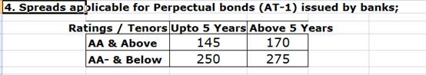

**New format**

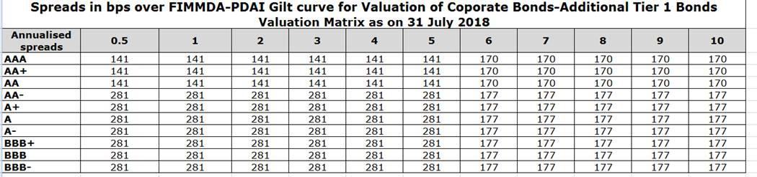

D.V.S.S.V.Prasad

Chief Executive Officer,

Fixed income Money market& Derivatives association of India(FIMMDA),

2nd Flr, United India Bldg,

Sir P.M.Road, Fort,

Mumbai 400 001.

Tel: +91 22 2269 0321-26

Fax:+91 22 2262 6454

Hand phone/Mobile: +91 9004780777

Website: [www.fimmda.org](http://www.fimmda.org)

E mail: [ceo@fimmda.org](mailto:ceo@fimmda.org)